Name:

Acids and Bases

ACT/MME prep

Acids Bases

Acids are compounds that add H+ ions to a water solution.
Cl-
Bases are compounds that add OH- ions to a water solution.

Na+
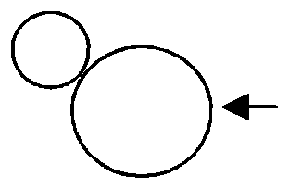

H+
Cl-
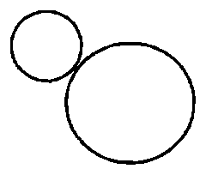

In water

H+ H+ ion
Na+
H
O-
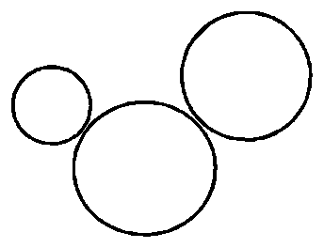

In water
H
O- OH– ion

HCl— Hydrochloric acid: a very strong acid.
In water HCl breaks up (dissociates) making H+ ions.
NaOH— sodium hydroxide: a very strong base.
In water it breaks up (dissociates) making OH– ions.

Many of our foods are acidic: citric
(lemons; oranges); apples; tomato sauce.

Acids taste sour and feel “squeaky”
when you rub your fingers together.
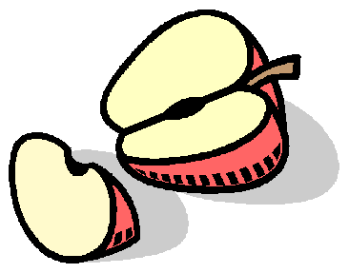

Many of our cleaning products are basic (ammonia [Windex]; soap; bleach) because they neutralize acidic food.

Bases taste bitter and feel slippery.
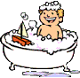

Strong acids and bases —ionize almost completely in water, contributing many ions.

Strong acids and bases can burn your skin or eyes.
Weak acids and bases—ionize incompletely, contributing just a few ions.

pH—The Measure of Acids and Bases

Strong acids
Acids

Weak acids
Neutral

Weak bases
Bases

Strong bases

0 1 2 3 4 5 6
7 8 9 10 11 12 13 14

Concentrated | Lemon | Vinegar | Distilled | Baking | Bar | Ammonia | Concentrated
HCl | juice |  | water | soda | soap |  | NaOH

Neutralization (Titration)

When acids and bases are mixed they neutralize each other. Equal concentrations of acids and bases make neutral salt water.
Diluting Acids

Never add water to a concentrated acid!

H
H+ + O-
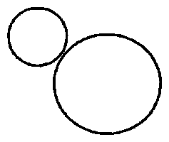

H+ H+
→ O-
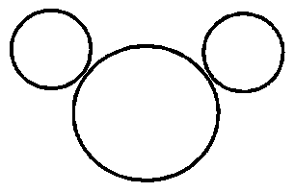

When acid compounds are dissolved in water, heat is produced (sometimes a lot of heat). Acids are more dense than water, so if you add water to
a concentrated acid, water sits on top and can

H+ + OH− → H2O

A typical neutralization reaction: HCl + NaOH → NaCl + H2O Acid + Base → Salt Water

water
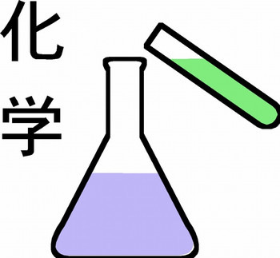

acid

flash boil (quickly boil). The boiled water can splash up burning you with hot water and acid. If the acid is added to water it sinks thru the
water and is diluted

Chemists call ANY ionic compound a salt. NaCl is a special salt: table salt.
One of the products
of a titration
is always water!
safely.

Always add acids to water!

cstephenmurray.com

Legal copying of this worksheet requires written permission.

Copyright © 2006, C. Stephen Murray

Name:

Plants and animals need water close to neutral (pH 7) to survive.

Due to pollution from combustion reactions, rain today can be acidic. Raid less than pH 5.6 we call acid rain.

Acid rain can kills plants, cause asthma and other physical problems.
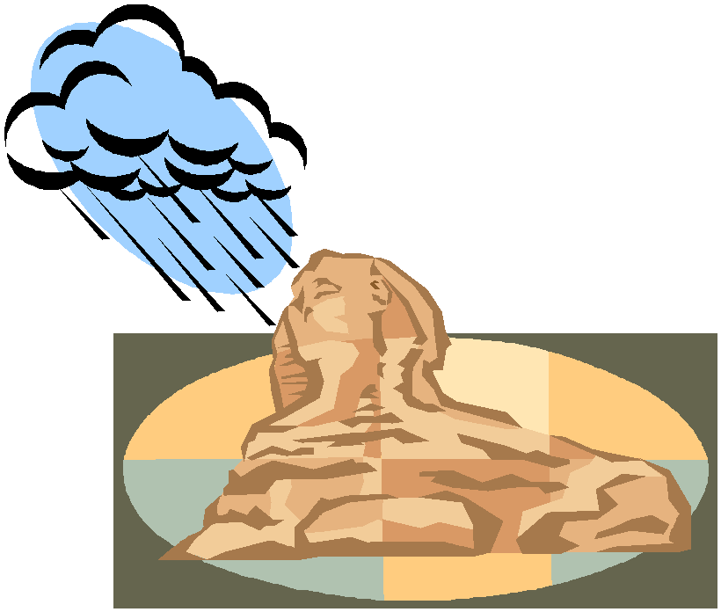

pH and Acid Rain

ACT/MME prep

Acid rain also eats away statues and historical landmarks.

The Roman ruins, the pyramids of Egypt, and other treasures of the world are being slowly dissolved away by acid rain. More damage has been done in the last century than in the last 2,000 years.

Without stopping pollution (and acid rain)
these treasures may be lost forever.

1. Acid

2. Base

3. Neutral

4. Neutralize

5. Acid Rain

6. A Salt

7. Table salt
A. To mix acids and bases to cancel each other out and make salt water.

B. A compound that adds H+ ions to water. C. Any ionic compound.
D. Equal number of H+ and OH– ions;
water is an example.

E. A compound that adds OH– ions to water.

F. A compound of sodium and chlorine.

G. When pollution causes rain to be acidic
(pH of less than 5.6).
1. pH

2. Salt Water

3. Strong Acid

4. Weak Base

5. Weak Acid

6. Titration
A. The measure of acids and bases.

B. A compound that adds a few OH– ions to water.

C. To neutralize an acid with a base.

D. The product of a neutralization reaction between an acid and a base.

E. A compound that adds a few H+ ions to water.

F. A compound that adds a lot of H+ ions to water.

HCl

H2(SO4)

Mg(OH)2
Acid or Base?

H2(CO3)

NaOH

Ca(OH)2

Acid or Base?

H3PO4

LiOH

HNO3
Solution A (pH 4); Solution B (pH 2)
Which one has more H+ ions? Which one has less OH– ions? Which one is more basic? Which one is more acidic?

Solution A (pH 11); Solution B (pH 13)

Has fewer OH– ions

Has more H+ ions

Feels squeaky clean

Has fewer H+ ions

Tastes bitter
Has more OH- ions

pH of 0 to 7

pH of 7 to 14

Feels slippery

Tastes sour

Which one has more OH- ions? Which one has less H+ ions? Which one is more acidic? Which one is more basic?

What is the product of every titration?

Should you add an acid or a base?

You need a pH of 6.2; you have a pH of 5.1. You need a pH of 12; you have a pH of 13.4. You need a pH of 7; you have a pH of 11.2. You need a pH of 4; you have a pH of 2.3.
Antacids neutralize stomach acid. What is an antacid really?

Finish these neutralization reactions: (balance the salt, too).

HBr + Mg(OH) →

HS + Li(OH) →

How do you safely dilute a concentrated acid?

